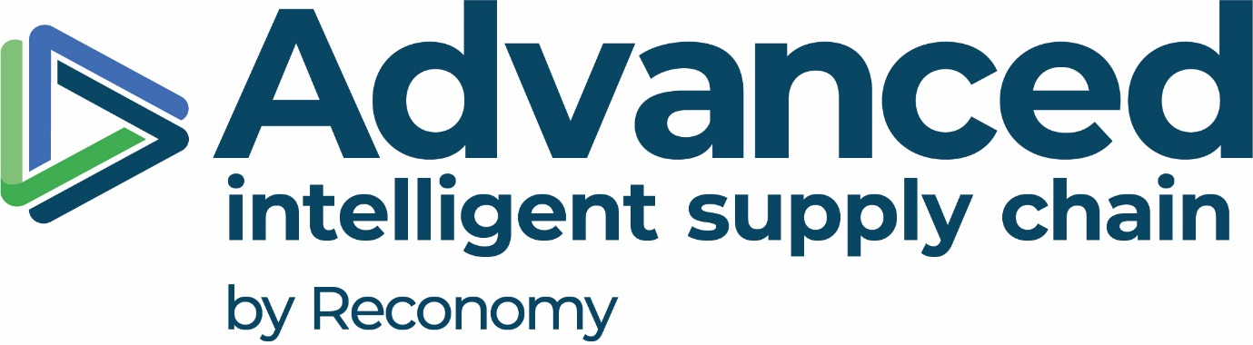

Labour and Human Rights Roadmap

Aligned with Reconomy Group Anti-Slavery, Human Trafficking and Human Rights Policy

Next review date: 24/03/25
Contents

Introduction 3
Scope 3
Roadmap objectives 3
Integrated Labour & Human Rights Performance Targets 4
Health and Safety of Employees 4
Working Conditions and Fair Pay 4
Diversity, Equity and Inclusion (DEI) 4
Social Dialogue and Employee Engagement 4
Training and Career Development 4
Child Labour, Forced Labour, and Trafficking Prevention 5
Discrimination and Harassment 5
External Stakeholder Human Rights 5
Governance and Allocation of Responsibilities 5
Remediation 6
Company communication 6
Endorsement 6

Introduction
Advanced Supply Chain Group Limited (ASCG), a Reconomy Group company, is committed to protecting and promoting the fundamental rights of all employees, workers, and partners. ASCG has developed this Labour & Human Rights Roadmap to outline structured actions, measurable goals, and governance mechanisms that ensure the organisation fosters ethical labour practices across all global operations. This document should be read in conjunction with Reconomy Group RGPOL_005_modern_slavery.

Scope
This roadmap applies to all activities undertaken by ASCG, suppliers and partners and aligns with the overarching policies and standards of Reconomy Group.
The roadmap covers all ASCG operational, administrative, and strategic activities across the following sites and regions:

Country | Sites Name | Address
United Kingdom | Head Office – Bradford (J26) | Unit 4, Interchange Way, Oakenshaw, Bradford, BD12 7AZ
United Kingdom | ASCG Corby (Site 1) | Units 1–3, Eismann Way, Corby, Northamptonshire, NN17 5ZB
United Kingdom | ASCG Corby (Site 2) | Hunters Point, Brakey Road, Corby, Northamptonshire, NN17 5JE
United Kingdom | ASCG Sheffield | PLP Smithywood, 6 Cowley Way, Sheffield, S35 1QP
UAE | ASCG International | Al Fattan Plaza, Airport Road, Office 712, Al Garhoud, Dubai, UAE
Germany | ASCG Germany – Nettetal | Herrenpfad-Süd 40, 41334 Nettetal, Deutschland

Objectives
ASCG is committed to achieving the following general human rights objectives:
- Promote a safe, healthy, and inclusive workplace.
- Ensure fair wages, working hours, and conditions.
- Prohibit child labour, forced labour, and modern slavery.
- Prevent all forms of discrimination and harassment.
- Support freedom of association and collective dialogue.
- Provide opportunities for employee development.
- Respect the rights of external stakeholders affected by our operations.

Integrated Labour & Human Rights Performance Targets
ASCG is committed to the following targets, with the respective baseline year being 2021:

Health and Safety of Employees
- Maintain a 0% recordable workplace injury rate by Year 2028 through the implementation of proactive safety training and risk mitigation strategies.
- Conduct 100% risk assessment of all operational sites annually.

Working Conditions and Fair Pay
- Maintain 100% of employees are paid at or above the Living Wage by 2028.
- Conduct annual pay equity reviews within banded areas of the business.
- Maintain 100% of employees are paid at or above the Minimum Wage by 2028
- Conduct employee satisfaction surveys on working conditions every year.

Diversity, Equity and Inclusion (DEI)
- Achieve 50% gender representation in management and leadership roles by 2028.
- Publish an annual Gender Pay Gap Report starting 2024, with transparent reporting and improvement actions.
- Provide mandatory DEI awareness training to 100% of employees by 2028.

Social Dialogue and Employee Engagement
- Establish active employee feedback and consultation forums at 100% of operational sites by 2028.
- Guarantee that 100% of employees are free to join or form trade unions or employee representation groups without fear of retaliation by 2028.
- Maintain the “Employee Voice Forum” across all sites by 2028, providing a safe and inclusive platform for employees to raise concerns and contribute to workplace improvements.

Training and Career Development
- Provide a minimum of 5 of training per employee per year by 2028.
- Ensure 100% of new hires complete induction training within their first 30 days.
- Achieve a 20% increase in the average training hours per employee by 2028.

Child Labour, Forced Labour, and Trafficking Prevention
- Ensure 100% of employees receive training on child labour, forced labour, trafficking prevention, and modern slavery by 2028.
- Conduct risk assessment of all operational sites annually.
- Maintain Zero incidents regarding child labour, forced labour, trafficking prevention, and modern slavery by 2028.

Discrimination and Harassment
- Provide anti-discrimination and harassment training to 100% of employees annually.
- Maintain a zero-tolerance policy with all reported cases investigated within 5 working days.

External Stakeholder Human Rights
- Conduct human rights impact assessments on 100% of new international expansions by 2028.
- Collaborate with at least 1 local community organisation per region on human rights initiatives by 2028.

Governance and Allocation of Responsibilities

Figure 1 Labour and Human Rights Roadmap Governance structure and responsibilities

Review process

The roadmap will be reviewed annually by the Managing Director or sooner if triggered by:
- Legislative or regulatory changes
- Grievances, incidents, or internal audits
- Reconomy Group strategy updates

The review process ensures that ASCG continues to uphold high standards in labour and human rights.

Remediation
Should modern slavery, forced labour or human rights breaches be detected within the business and supply chain, there should be an appropriate escalation process. We would refer to the police and seek advice (in the UK) from the NCO Unseen helpline 0800 0121 700 and report via the Unseen modern slavery website.
Company communications
- The roadmap is available on ASCG’s intranet and external communications portal.
- All employees and contractors will receive onboarding and refresher briefings.
- Awareness campaigns and training modules will be promoted quarterly.

Endorsement
This roadmap is endorsed by ASCG’s senior leadership and reflects our commitment to building an inclusive, safe, and ethical workplace. The roadmap aligns with Reconomy’s overarching standards set in the RGPOL_005_modern_slavery statement and aligns with global best practices.
Approved by:

Last review date: 24/03/25

